Fold Recognition from Sequence Comparisons
Kristin K. Koretke, Robert B. Russell, and Andrei N. Lupas
PROTEINS, Suppl 5, pp. 68-75, 2001
Abstract
We applied a new protocol based on PSI-Blast to predict the structures of fold recognition targets during CASP4.
- Introduction
An evaluation of the outcome suggested that most successful predictions were due to the detection of distant sequence relationships.
- Methods
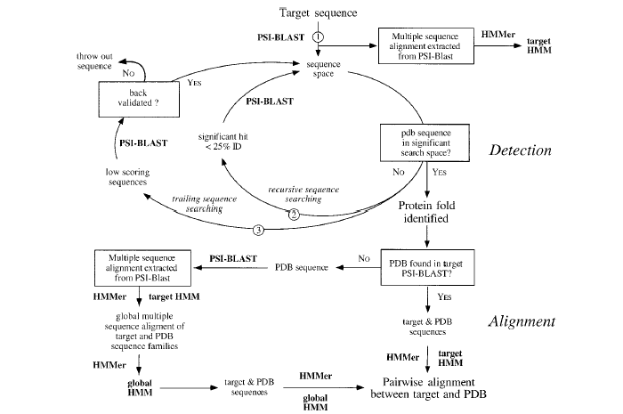
Created by : Rei-Sing Cheng
Date : Sept. 18, 2002

